Name:  Teacher : | ____________________________________  ______________________ |  | Date:_________
 | Year 12 Foundation  /21  Task 3: Test 1  Full working out MUST be shown to get full marks for each question.
Total Time: | 40 minutes
Weighting: | 6%
Equipment: | To be provided by the student: Pen, pencil, ruler, scientific calculator, INB

- For each of the following questions, decide which operation you would use to solve the problem and then work out the answer:
Question | Operation  (X + ÷ or -) | Working out and answer
A group of 5 friends go to a restaurant and decide to split a $150 bill equally between them. How much do they each pay?
In Watertown Brand Outlet, a top originally cost $56 but there is a saving of $17. What is the new price?
For a Fremantle Dockers away game, 16 buses of 52 people each travel to the game. How many people in total?
In Hungry Jacks, it costs $5.95 for a super stunner meal and 60c to “go large”. What is the total cost for a large meal?
- marks)

- Mrs Wood goes shopping to Woolworths. In her head, she estimates the bill to be $21 for a family of 3 for a week of groceries (food shopping).
- Is this a “reasonable” answer? Or has Mrs Wood made a mistake? Explain your reason.
(2 marks)

- A group of 4 friends go on a road trip (in one car). In total they use 175 litres of fuel costing $1.50 per litre. Calculate how much each person has to pay to the nearest 5c.
Show your method.
(3 marks)

- The following calculation has a mistake in it. Circle any mistakes and write the correct method underneath.
I wanted to work out the total cost of 5 cookies at $3 each and 3 bottles of Coca-Cola at $2 each.
5 x 3 - 5 x 2
15 x 10 = $150

5
5
5 x

(3 marks)

 | Minimum Temperature Perth | Maximum Temperature Perth | (a) | Write the minimum temperature in degrees Celsius.
 | 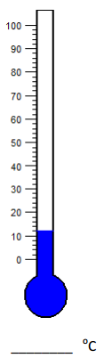 | 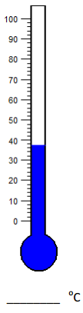
 |  |  | (b) | Write the maximum temperature in degrees Celsius.
 |  |  | (c) | What is the range of temperature for that particular day?
 |  |  | (d) | What season would you likely expect this range of temperatures in Perth.

5 marks (1, 1, 2, 1)

END OF TEST

